Adding MMCGME Required Documentation into Checklists
MMCGME staff needs to accept all “MMCGME Required Documentation so steps have been created for you to incorporate into your checklists:
The following steps have been created for your use:
- *2018-2019 MMCGME Personal Information Data Form
- *MMCGME Prior Training Form 2018-2019
- *MMCGME-Diploma 2018-2019
- *MMCGME-ECFMG Certificate 2018-2019
- *MMCGME Program Completion Certificates from Previous Training Programs 2018-2019

Adding MMCGME Steps to checklists
- Click Add Existing Step
- On the view steps pane change the listing from Department to all Steps

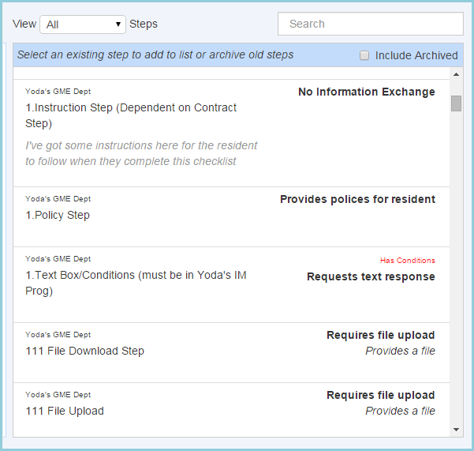
- Select an MMCGME step from the list above.
- Click View/Edit Step

5. Repeat steps until all MMCGME Steps are inserted in your checklist

