How to import data from ERAS Into New Innovations
If this is your first time doing the ERAS import your DIO will need will need to authorize the process. Contact MMCGME services for additional information.

Step #1: Marking Trainee as Will Start
- Log into your program(s) ERAS account
- Click on the “Applications” tab; and then the View Current Results” tab
- Check the box next to the names of the trainee who have matched to your program
- Scroll to the bottom of the list and click on the drop down: “action to perform on selected applicants”
- From the drop down, choose “Update Status” and click “Go”
- Under the “Application” section; check the “Will Start” column
- Click “Apply”

Step #2: Download ERAS file using API

Login into New Innovations and navigate from Personnel>Tools>Import ERAS Data

- Choose the appropriate program from the dropdown box
- Leave the box checked for Initial Program
- The status type is entered for you based on the program status mapping.
- The start date is entered for you based on the advancement section in the program
- The Post Graduate Year defaults to 1. Leave it at 1 if most people you're importing have that PGY
- Select the employer from the dropdown list. Make sure if the employer is different that you are updating the employer
- Select a Compensation Status (Optional)
- Enter the start/hire date (Optional)
- Keep the box checked to have the computer create a Username and Password on import
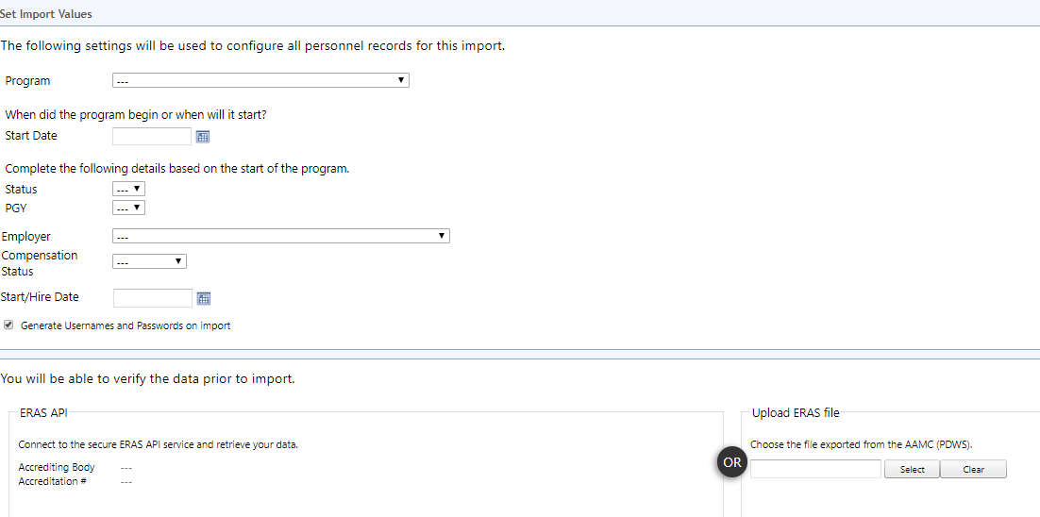
- Select Connect to API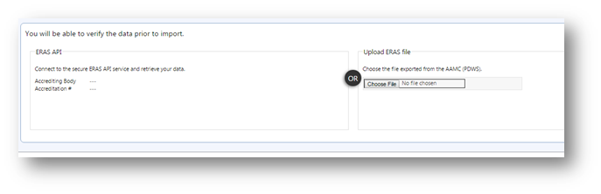
- Click Connect to API
- Click Continue
- The names of the people you selected from ERAS appear on this page.
- Reconcile any discrepancies- match any medical schools instructions below
- Click Continue

Matching Medical Schools (if necessary)
Medical School names must match exactly. If ERAS Medical Schools do not match exactly to a medical school in the RMS medical school list, the person will still be imported and a Training Record for their Residency/Fellowship will be created. However, the Education record listing the Medical School will not be created for that person. To match the Medical Schools during the process:
1. Select the appropriate medical school from the dropdown lists
2. Click on Match Medical Schools at the bottom of the page
3. Check the box for all those people to import. Check for possible duplicate at the bottom of this screen. See notes below.
4. Click Continue to import the data to the Personnel module

If you have any issues with the API please contact Lisa Gorman at Lisag@umn.edu

